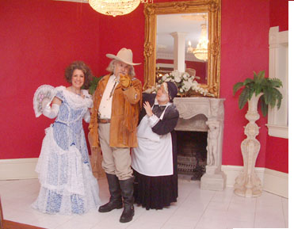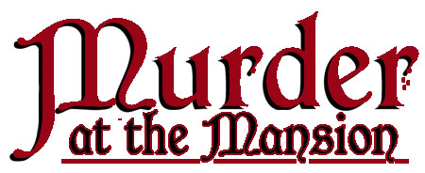

***You’re invited to ...***

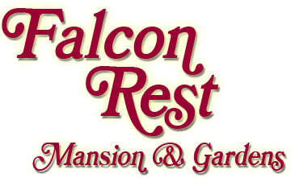

**2645 Faulkner Springs Rd. McMinnville, TN**

**931-668-4444  www.falconrest.com**

**Herschel Faulkner Age: 19**

Relationship: Only son of Clay and Mary Faulkner, second of five children

Personality: Smart, handsome. charming and mechanically inclined. but well known for his laziness.

Background: Herschel inherited his father's mechanical gifts. but not his work ethic. One time he was asleep on the lake bank across the road with molasses on his feet. When asked why, he said, "To keep the flies away from my head." In spite of his laziness. he and friends did make a bicycle trip in1896 from his uncle's home in Bell Buckle, Tenn., all the way to Mammoth Cave, Ky., and back.

**Herschel Faulkner**

Second child and only son of the Faulkners

* Falcon Rest’s fun-filled "whodunit" is based on actual characters from McMinnville, Tennessee, history in the late 1800s. The show is set at an 1897 dinner party given by wealthy manufacturer Clay Faulkner and his wife Mary to celebrate completion of their new Faulkner Springs mansion.. Guests enjoy a delicious meal as they participate in the play.
* The guest list includes the extended Faulkner family and McMinnville notables who really lived there in 1897, as well as nationally prominent individuals including Teddy Roosevelt, Susan B. Anthony, and Annie Oakley.
* Falcon Rest actors portray Clay and Mary Faulkner, but the real stars of the show are the audience members themselves who assume 1897 characters when they arrive. Guests wear a sign like the one at right identifying their character with details on the back. There are no lines to remember or pressure to participate, so they are free to ad-lib with the Falcon Rest players as much or as little as they like. Mr. Faulkner carries on an impromptu conversation with guests during dinner, and they can be counted on to come up with some pretty hilarious dialogue!
* When a dastardly murder mars the celebration, audience members help special guest star Buffalo Bill Cody discover which one of them is the culprit!
* In addition to the delicious meal and show, you'll enjoy a tour of Falcon Rest, the 1896 Victorian mansion called "Tennessee's Biltmore" by PBS

***The Victorian mansion***

***where history is fun.***

Contact Name

Phone * e-mail address

Cost *Deadline

Day, Month 00

Departure Time

Meeting Place